GDesign 2.4 / 3.0
User Manual

1. Introduction 2

2. GDesign in a glance 3

3. Using LSystems with GDesign 5
Symbols 6
Special symbols 7
Programmable symbols 10
Using Rules 11
Special rules 13

4. Subsystems 17

5. Options 19

6. Parameters and Display 21

7. Import and export files 22

8. Handling errors 23

Umberto Roncoroni
March 2017

GDesign 2.4 – 3.0 Manual

- Introduction

GDesign 2.0 is a 2D/3D free generative art application for Windows. With GDesign you can interactively build, test, and edit complex 3D models using DOL, Stochastic, Timed and Parametric LSystems, to experiment, explore and teach generative digital tools.

The goal of GDesign is not only to build 2D/3D models compatible with 3dsMAX, Rhino and POVRay, but to study and experiment different formal solutions using generative grammars.

This software was created for my Computer Science master tesis at PUCP, Lima, Peru and is continuously developed to improve its functionalities. Much of the funtions and tools implemented into the software were suggested by the classroom experience, infact I have been using many versions of GDesign in my generative design classes at the Architecture Faculty of the San Martin de Porres University located in Lima, Peru.

- GDesign in a glance

GDesign is divided into two main forms: the drawing or display form and the gramar form.

2.1 Installing

- Copy the GDesign folder into the c drive main directory. C:\GDesign
- To begin, open the Grammar window, where you build your generative grammars and assign 2D or 3D objects to your symbols.
- Save the grammar, set the export options, then press Launch.
- Choose iterations, object size, angle and decay. Default are 50, 5 and 30 degrees.
- Choose standard or stocastic or context sensitive LSystems buttons in the Design window.
- Change viewports or parameters, or go back to the grammar window to edit your LSystem.
- To render your model, you must export the file to POVRay, Rhino or 3DSMax, using their script formtas or .STL file format.
Remember to check the .ms or .pov options, then load the file in POVRay or 3DSMax (without exiting GDesign) and run the scripts.

2.2 The interface

The Display form.

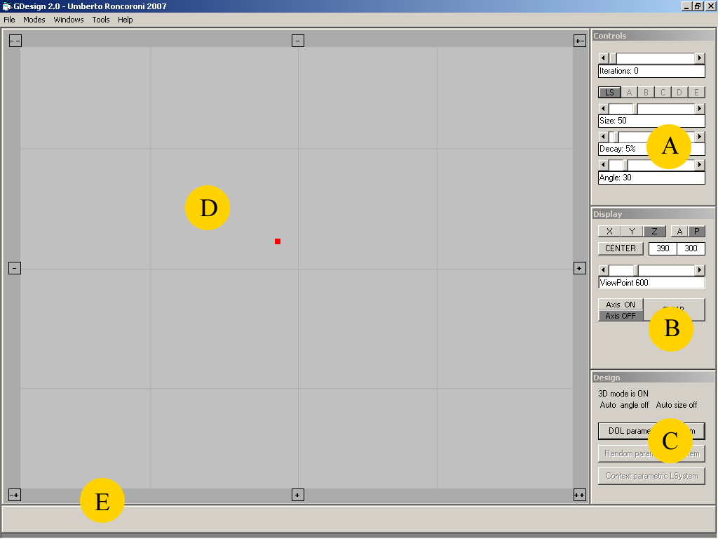
A: Controls palette, B: Display palette, C: Design palette; D: Canvas; E: Messages

The Grammar form.

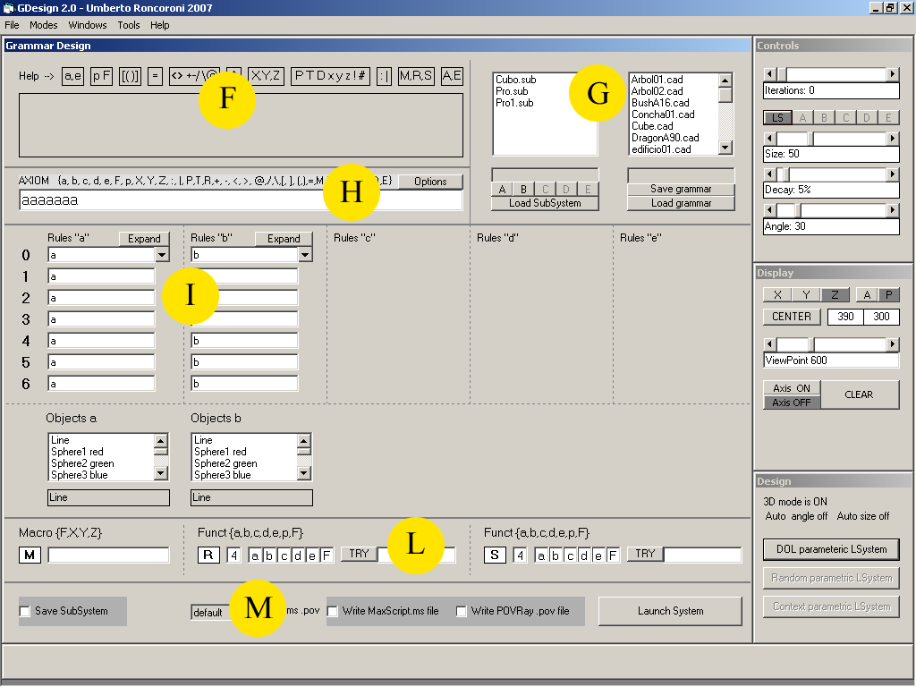
F: Help; G: Save and Load grammars and subsystems; H: the Axiom text tfield;
I: Rules and objects lists; L: Macro and Functions; M: Export options

The Options form.

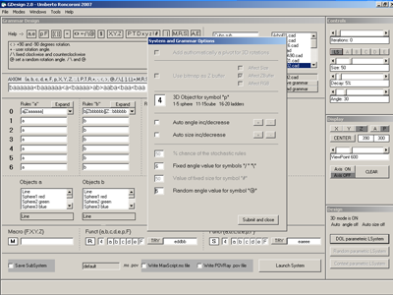

3. Using LSystems with GDesign

LSystems are string substitution systems, where the system is a string of symbols that can be used to represent 2D or 3D graphic objects (such as fractals or trees) moving a turtle like in LOGO.

Like generative grammars, you have to figure out a set of rules that are applied to each symbol, so that it can generate new sets of symbols. The process can be iterated many times, the only limit being memory and speed, infact these systems can grow up pretty fast.

LSystems come in many flavors: deterministic or standard LSystems, stochastic LSystems (with random rules), parametric LSystems, context sensitive LSystems (where rules depend from the neighborhood of the symbol) and timed LSystems.

GDesign has its own set of special symbols and rules that provide a kind of LSystems programming language, especially suited for artists, designers, and teachers and for everybody who wants to experiment with generative design. In the Grammar window there is a dictionary that explains how to use the language.

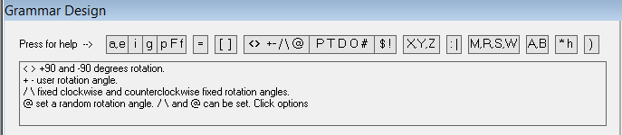

Example

Axiom=aP+b
a=a[T-b]
b=D+a+a

0. aP+b
1. a[T-b]P+D+a+a
2. a[T-b] [D+a+a] P+ a[T-b] a[T-b]

If you assign to “a” a red cube, and to “b” a blue sphere, then the parser will:

Draw a red cube, open a branch, then rotate along the Y axis and draw a blue sphere, restart from the position before the branch, rotate along the X axis, draw a red cube, rotate along the same axis, draw a red cube, restart from the position befote the branch, rotate along the Z axis, draw a red cube… etc.

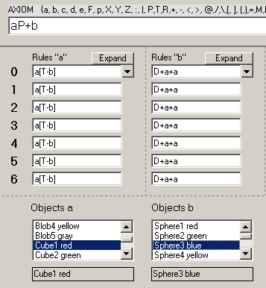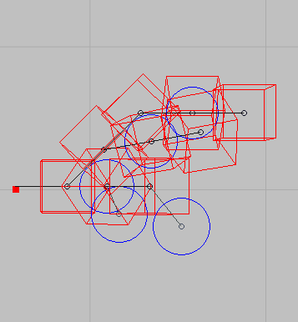
The grammar whindow Objects

First you must write the axiom, then the rule for your symbols. You can use a different rule for each iteration fro 0 to 6 /7 in total).
Then assign an object the symbols. Some symbols mus be set in the Option window, that you can open from the Grammar window.

Symbols that are not included in the dictionary will be ignored.

3.1 Symbols

a, b, c, d, e Non terminal symbols, it means that they have a set of rules to produce new symbols. Any legal symbol can be used in the rules.

F, f Terminal symbol. Moves the turtle by an empty unit. The unit is fixed for all objects in the parameter palette of the Display window. “f”, on the other hand, lets you set a specific object size, different from the main unit.

g Non terminal. Always double itself g = gg.

i Non terminal. “i” rule is interactive, you have to specify the production string interactively in real time.

p, v Terminal symbol. You can assign a graphic object to these symbols. “v” is not available in the free edition.

= Terminal symbol. “=” freezes a symbol, so that the production is delayed by 1 iteration. You can use many “=” together, blocking the production longer.

A, B, C, D, E Terminal symbols. These represent subsystem, say a complete LSystem that can be nested inside the main system.

M, N Terminal symbol. It is used to move an object in a specific location, so that you can use the same movement many times. It is very useful with subsystems, to align an object to a specific point of the subsystem. “N” is not available in the free version.

R, S, W: Function symbols. “R” and “S” represent functions that return a random string of symbols. You can define how many symbols will randomly appear; the length of the string can also be randomized.

) This symbol is used to save the current random value of “R”, “S” symbols. Every instance of “R” and “S” returns a new random value, if you write “)” before “R” or “S”, the symbols get the last generated random number. This lets you take good control of random processes.

X, Y, Z Terminal symbols. Represent the direction of the turtle.

$ Terminal symbol. Inverts the direction of the turtle

O: Terminal symbol. Returns the turtle to the starting point

P Terminal symbol. Pan: Align the rotation axis to the Z axis. It must be followed by a rotation angle (symbols +, -, / ,\, @).

T Terminal symbol. Tilt: Align the rotation axis to the Y axis

D: Terminal symbol. Dolly: Align the rotation axis to the X axis

+ , - Terminal symbols. Increase or decrease interactively the rotation angle

< , > Terminal symbols. Change the rotation angle by +-90 degrees

/ , \ Terminal symbols. Change the rotation angle by a fixed value

@ Terminal symbol. Change the rotation angle by a random value

# Terminal symbol. Undo the last rotation

: , | Terminal symbol. Increase or decrease the object size

[ , ] Terminal symbols. Open and close branches, store and retreave data

{ , }: Terminal symbols. {,} with integer n=1-9 duplicate n times the string inside {,}. Example: p{3ab}= pababab. {,} and the integer are automatically deleted. This option is not available in the free version.
3.2 Special symbols

Gdesign includes some new symbols to support special tasks or effects, that are not supported by other LSystems packages.

= This symbol lets you freeze another non terminal symbol, so you can temporize the production of this symbol.
It will desappear authomatically alter 1 iteration.

$ Revers the movement direction, if you are going up, then you will go down, if you go to the left, you will go to the right, etc.

M This is a macro useful to set objects into position without using too many F, X,Y,Z. Write in the textbox the string of movements you want, then use the M symbol in your axioms or rules. This is very useful with subsystems (see below).

R, S These are random functions. You have to set how many random symbols you want to generate, then choose which symbols will be included in the random strings, then use R or S or both in your rules.
When the parser finds a R or S, it will expand the symbol into the given random string. Note that for every R or S in the system the strings will be different.

u, w These are final symbols, you can use them anywhere in the rules, but will produce only in the last iteration (only in GDesign 3.0).

K, J K generates a random X, Y or Z direction, while J a random rotation axis. (only in GDesign 3.0).

Example of “=” usage:

Axiom: a=ab
a: bP+b
b: ab
  - a=ab
  - abP+bab note the red a that doesn’t change, = is destroyed
  - bP+babP+abbP+bab now all the a’s are producing

Example of function R and S usage:

Axiom: a
a: bP+b
b: MRP+MS
M: XFY$F$F
R: a random string of 3 ab symbols
S: a random string of 5 abF symbols
- a
- bP+b
- MRP+MSP+ MRP+S
R = aab S = baFbF
R = bab S = bFaba
- XFY$F$FaabP+XFY$F$F baFbFP+XFY$F$FbabaP+bFaba

fig. 7) The text fields in the grammar window to set M R S strings. Pulse “TRY” to preview the strings.

Symbol “!”. Inverts de current angle, it is useful to créate simmetric forms. The inversion can be multiplied n veces. For example, the string “aaaP+aaa!aaa”, with “+” set to 30 degrees, and multiplier set to 2, the first rotation “P+aaa” is clockwise rotiation of 30 degrees of three symbols “a”, and then a counterclockwise rotation “!aaa” of 60 degrees of three symbols “a”. To set “!”, use the Option window.

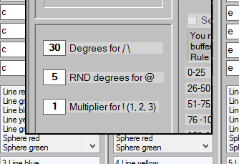

“P+aa+%aa+%aa+%aa+%aa+%aa+#aa+%aa+%aa+%aa+%aa+%aa#aa+%aa+%aa+%aa+%aa+%aa#aa+%aa+%aa+%aa+%aa+%aa”.

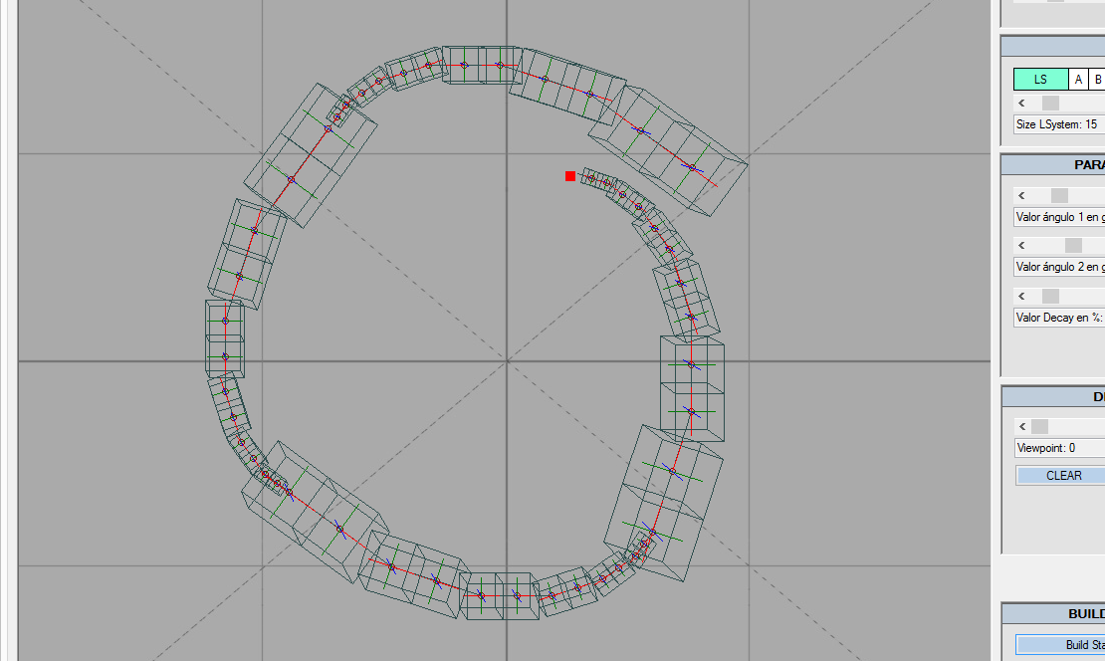

Symbol “?”
This symbol is used to generate a sequence of rotation, with an angle compueted with trigonometric functions ort a set of data that you can import through a text file. This option is not available in the free edition.

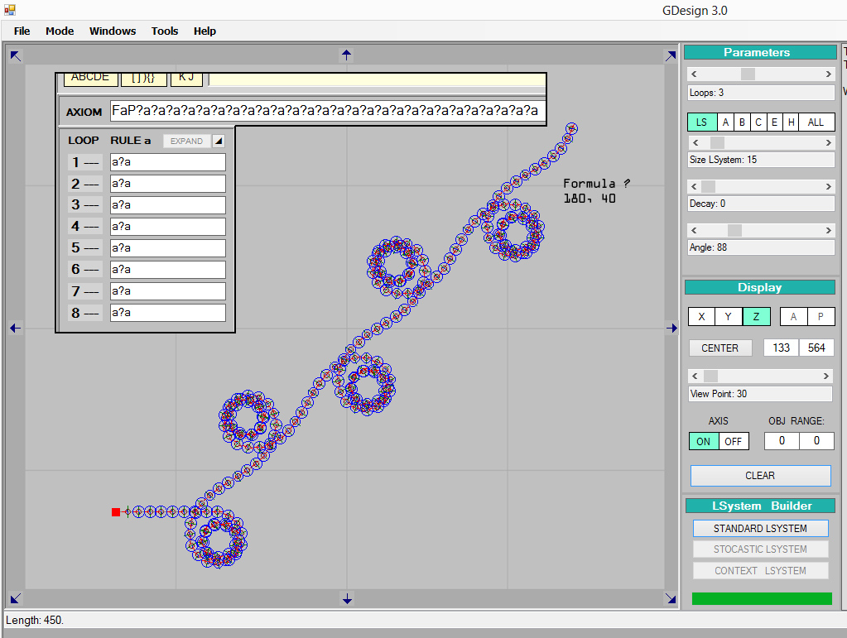

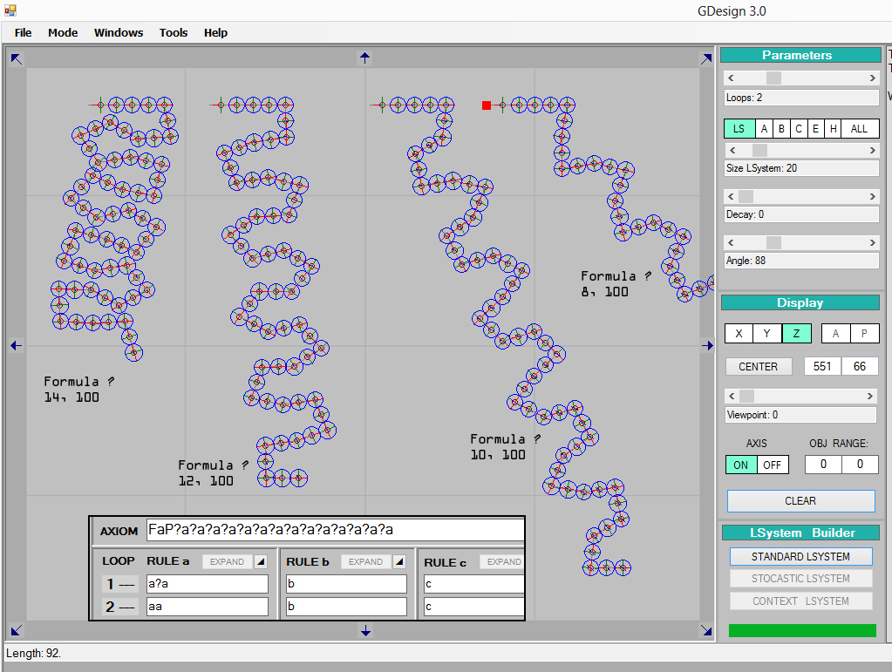

3.3 Programmable symbols

These symbols are available only with the commercial version GDesign 3.0 using an add on (free for GDesign 3.0 users).
These symbols let use the LSystem process as a programming language, with loops and go to.

Go to symbol “r”
“r” lets you use any rule of any symbol, ignoring the linear sequence.

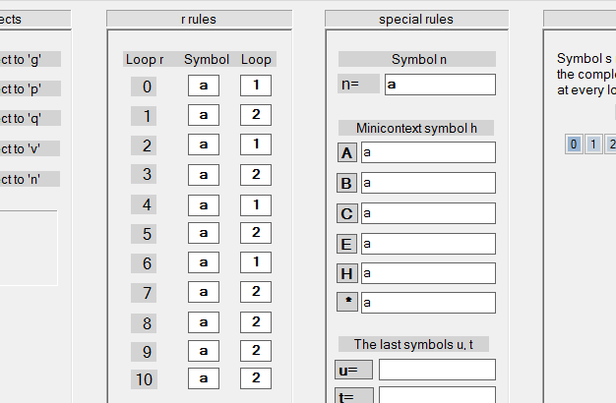
Help y menú de reglas para el símbolo “r”.

For example:

- “r”  ”2a”
- “r”  ”4b”
- “r”  ”1a”
- Etc.

This means that in iteration 1 “r” will be substituted with rule 2 of symbol “a”, while “r” in the 2 iteration will be substituted with rule 4 of symbol “b”, etc.

Recursive symbol “s”
“s” will be susbstituted with the LSystem string of the previous step.

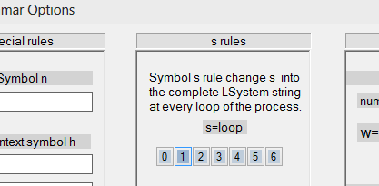
Nested system symbol “n”
It is like symbol “g”, but ther user can set the rule in the Options window. “n” can be reset using symbol ”0”. You can also use a symbol “ñ” inside “n” rules, “Ñ” has its own rule and it duplicates matching the value of the current “n”.
In the LSystem :

“aa[YTn]aa[YTn]aa[YTn]aa[YTn]aa[YTn]“
“n”  “+p”

The first instance of “n” will produce “+p”, the second “+p+p”, the third “+p+p+p”, etc.

“aa[YT+p]aa[YT+p+p]aa[YT+p+p+p]aa[YT+p+p+p+p]aa[YT+p+p+p+p+p]

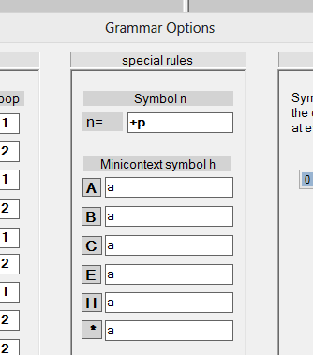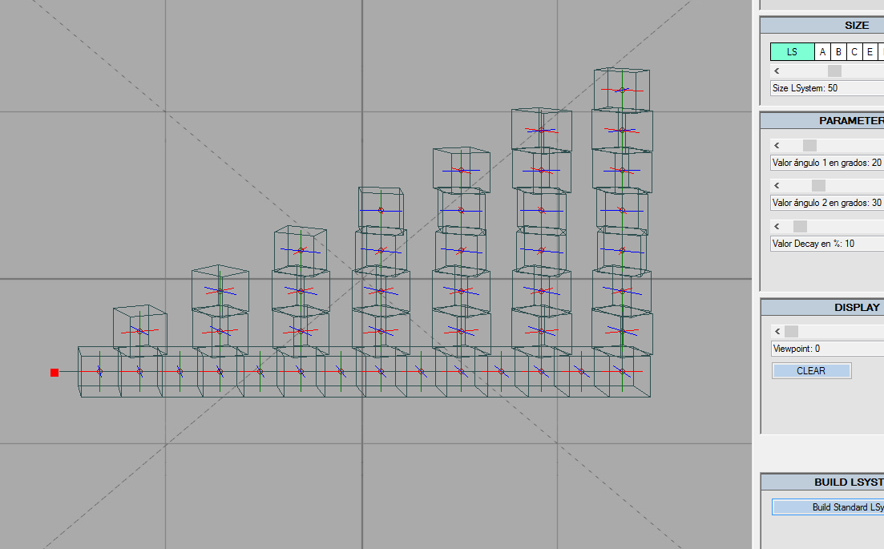

Example of “n” reset with symbol “0”:

“aa[YTn]aa[YTn]aa[YTn]aa[YT0n]aa[YTn]aa[YTn]aa[YTn]“

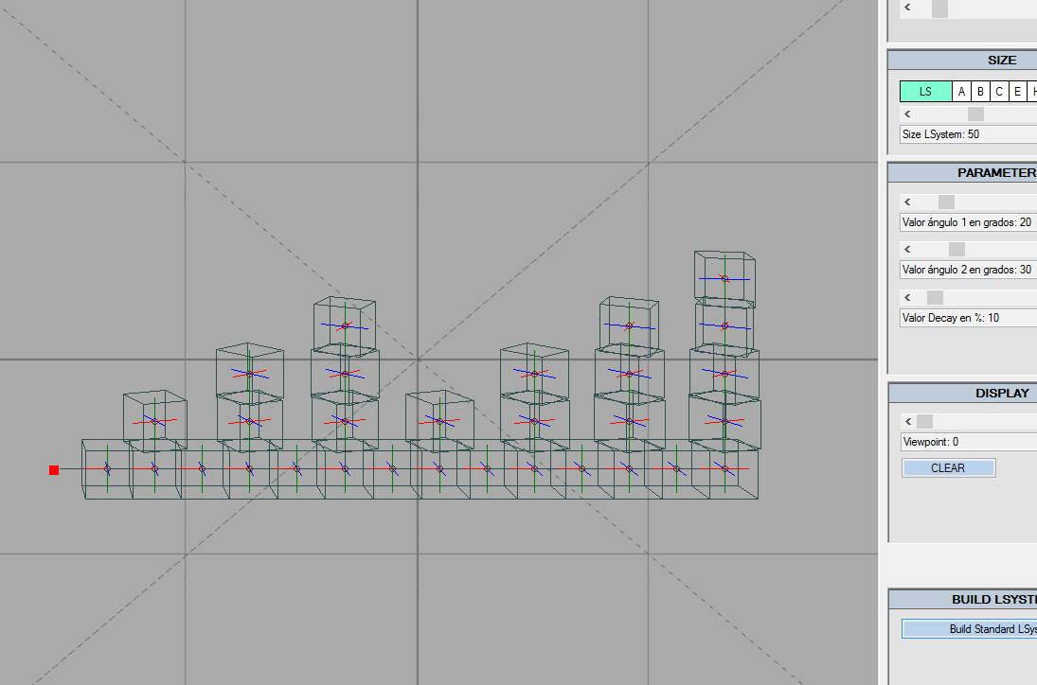

3.2 Rules

To build a LSystem, open the grammar window. During iterations, every non terminal symbol is sustituted by a new string of symbols. So the system grows up depending from the set of rules for every symbol included. You can use 5 non terminal symbols (a,b,c,d,e, say 5 sets of rules), 1 interactive rule, the symbol “i” and a fixed “double” rule, the symbol “g”.

3.2.1 Standard rules
You can set a different rule for each iteration. Note that iteration are limited to 7. It will be used the rule that matches the actual iteration. If you use an empty string as a rule, the symbol will be destroyed.

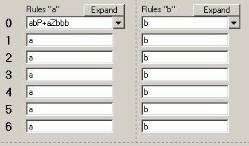
The standard rule palette

Numbers 0-6 are the iteration steps. Write a rule into each text field, or use the same rule for all the iteration. Use the arrow to copy the first rule downward.

3.2.2 Stochastic rules
It is also possible to use stochastic rules, the parser will choose at random between two rules for the actual iteration. Press the “expand” button to open the stochastic rule palette. Press “set rule” to assign the rule to the actual symbol.
You can set a different stochastic rule for each iteration.

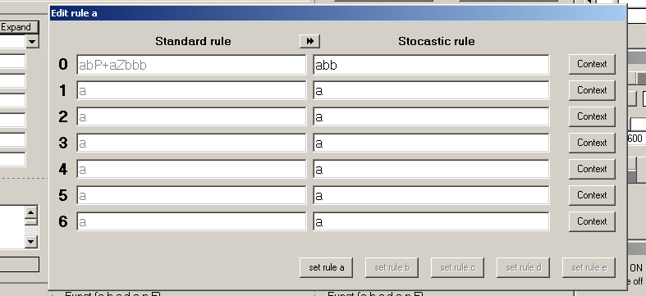
The stochastic rule palette

3.2.3 Context sensitive rules
To change to context sensitive rule, press the “context” button. You can set 5 different conditions. You must specify the left symbol and the right symbol (precedessor and successor) and the rule to apply. * is a jolly, it means any symbol.

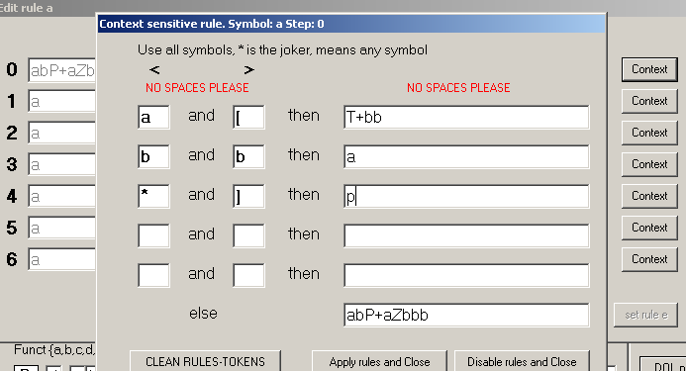
The context rule palette

These rules also come in hand when working with subsystems, so the growth process can react to special situations or objects.

3.3 Special rules

ZBuffer rules
These rules can be associated only with symbol “a”. Rules are linked with the brightness or gray value of a bit map. You must load a bit map (BMP, Targa) first to use these rules. There are 10 rules for 10 steps of 25 from 0 to 255. Moreover, you can also associate the size of objects with the image (see 5.2 Using bitmaps as Zbuffers).

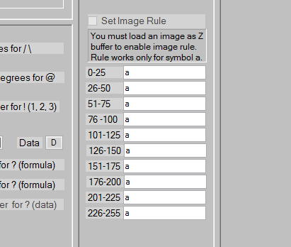

This option is not available with the free edition.

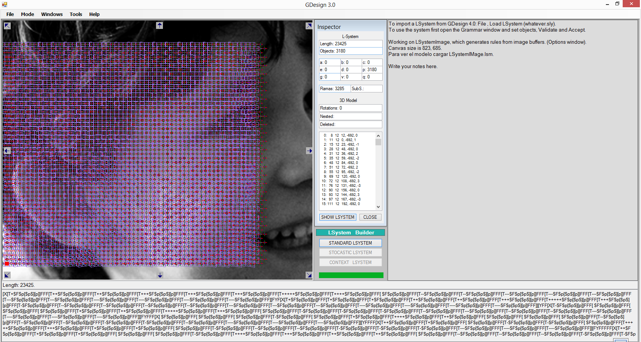
Positioning of a model to march a bitmap in the Display window

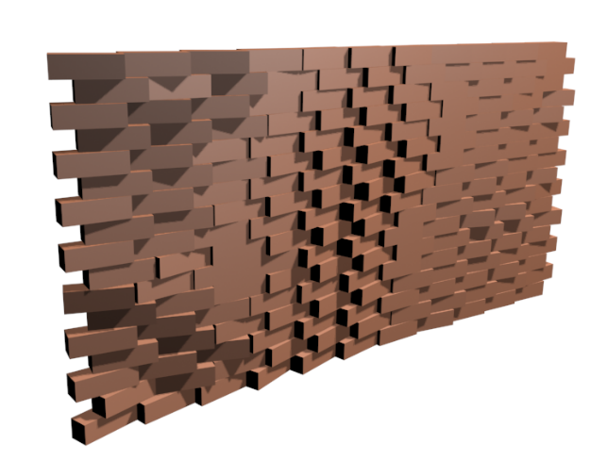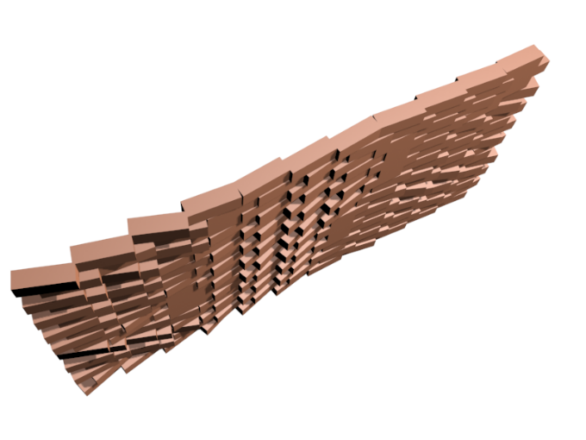
Bricks orientation with rules and bitmap

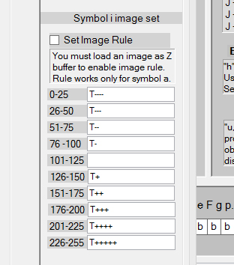
The rules
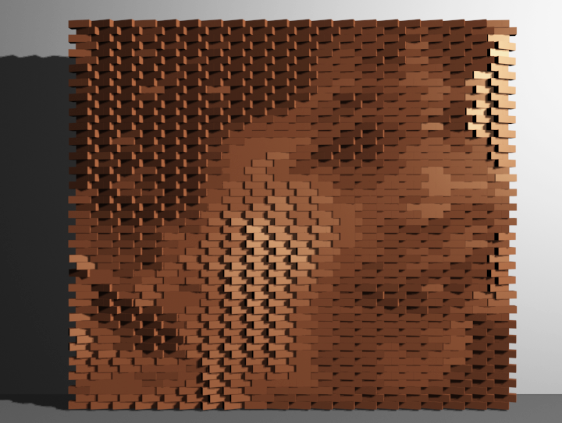
Rendering

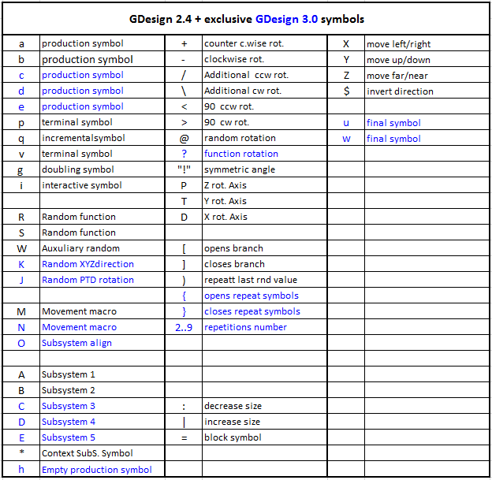
4 Subsystems

Subsytems are LSystems that can be embedded into other systems. There is one limit working with subsystems: you can’t use rotations, macros and functions. But you can move freely in the X Y Z directions, increase or decrease size, assign 2D or 3D objects and use branches. Subsystems are Terminal symbols, but you can weld a subsystem to any other non terminal symbol that will work like dummy objects.
You can build very complex objects made of subsystems and standard objects together. The best thing about subsystem is that you can change interactively the size of every subsystem and the size of the main system, so you can draw a lot of interesting effects in real time.

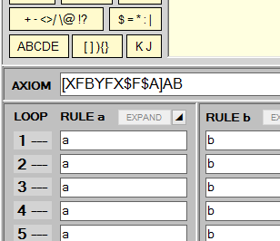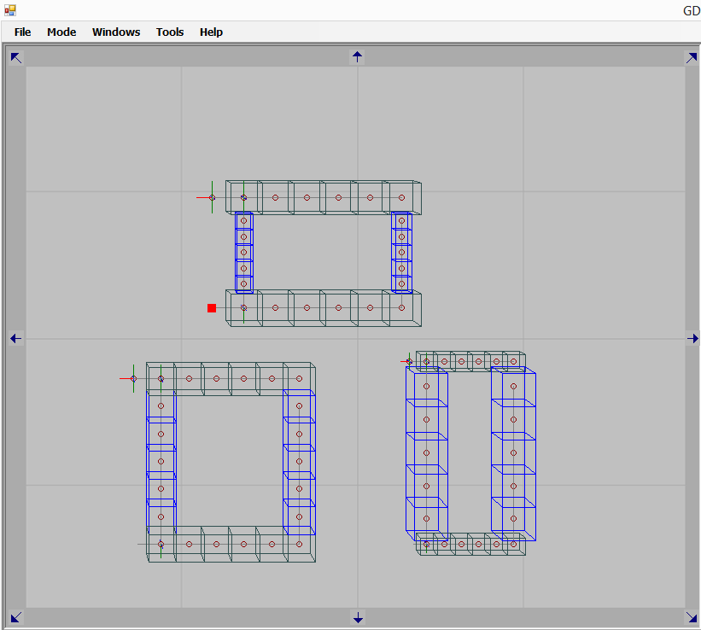
Grammar with A and B SubSystems SubSystems have independent size

It is difficult to align a standard object to a subsystem, because this object will stick to the last object of the subsystem. So you have to design your subsystem carefully and take care of alignments, ore use the M macro. To use subsystems, do the following:

- Build your system grammar; remember, no rotations, macro or functions…
- Assign the 3d objects ase usually
- Choose a name for the subsystem, validate the save subsystem option.
- Select A or B, load a subsystem that will be linked to this symbol.
- Create your system as usually, now you can rotate everything, subsystems included. Use A or B in your axiom or rules.
- You can save many subsystems, when you want to experiment with new sets, just load into A or B the subsystem you like.

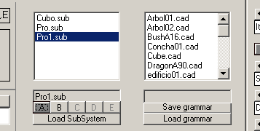
Load SubSystem file and select symbol reference

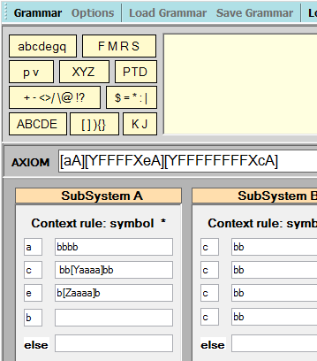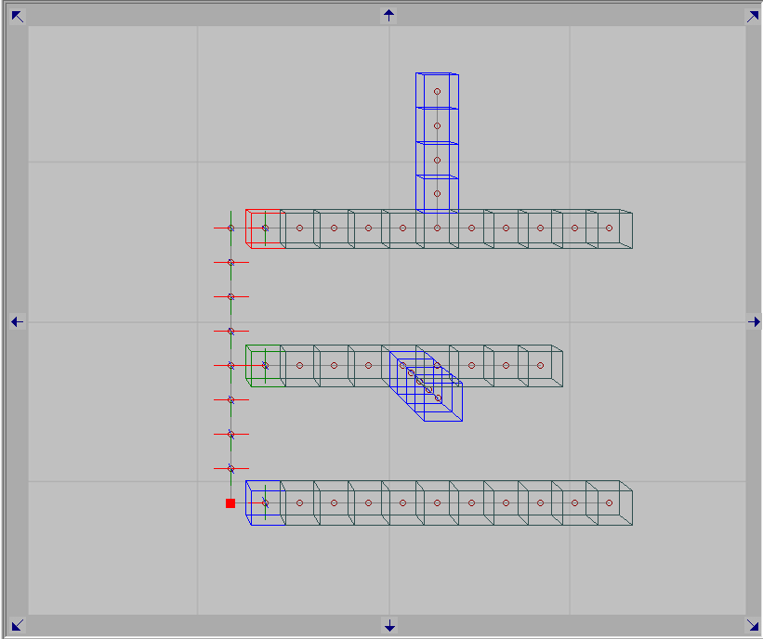
SubSystems programming menú. Effects of the programming, starting from bottom, using 1:
“a”, 2 “e” and “c”,.

You can use as many “*” as you want, with 5 context cases to handle different situations.

Align symbol “O”
Rhe alignmento of SubSystems depends from the first and last symbol positions. To make things easier, you can use symbol “O” to set the adequate postion settings to a specific Subsystem.

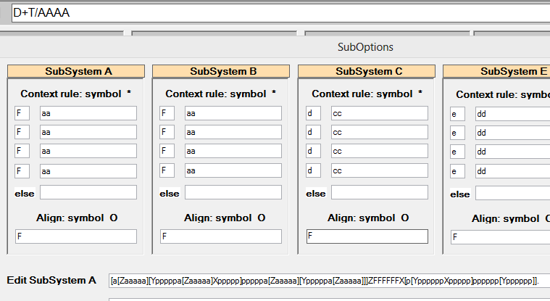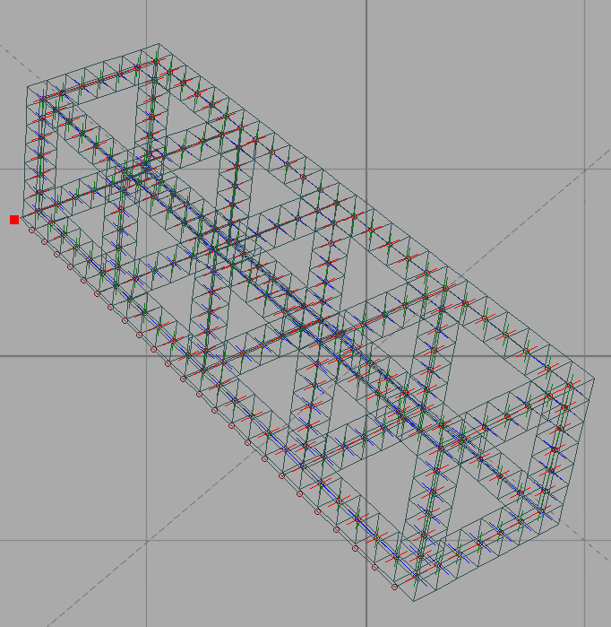
Alignment of SubSystems

- Options

In the option window you can set some general preferences:

- The graphic object for the Terminal symbol p
- Values for fixed rotations / and \
- Increase or decrease angle option. This is an automathic effect that increase or decrease the rotation angles every branch. So the last branches and the last symbols can be more or less rotated.
- Increase or decrease size option. This is an automathic effect that increase or decrease the size every branch. So the last branches and the last symbols can be bigger smaller. This is useful to build trees.
- Set the range for the random rotations.
- Activate the bitmap ZBuffer, that will modify the heights of the objects depending from the RGB values of the bitmap.

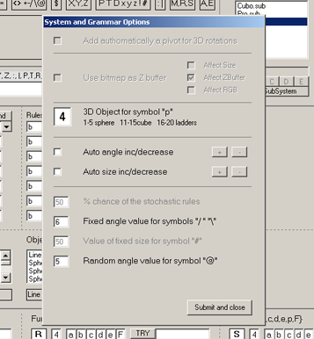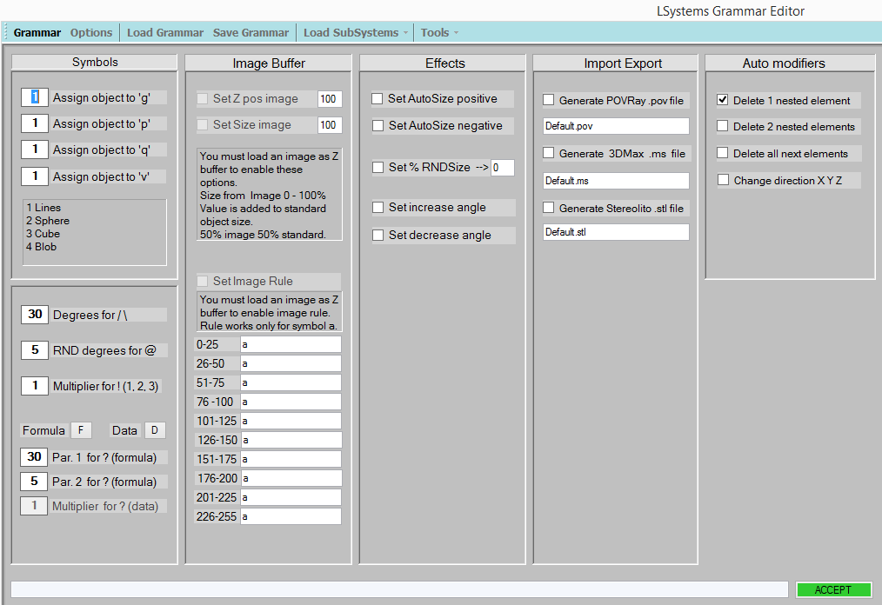
The Option window GDesign 2.4 GDesign 3.0

5.1 Graphic Objects, scripts

It is posible to link a 2D or 3D graphic object to symbols a,b,c,d,e,p,g.
This jeans that you can use up to 7 different type of cells. To assign a grtaphic object to a symbol, choose an object from the listbox control. The selected object will appear in the text field.

5.1.1 3D Objects:

Sphere: red green blue yellow and gray
Cube: red green blue yellow and gray
Blobs: only with POVRay files. Note that blobs in the canvas window are displayed as spheres.
Ladder: These objects are referentes to functions and macros for POVRay and 3DSMax. You can overload these scripts and use your own code. Do not change the file name though, because GDesign refers to every script by its filename.
Custom: The same as above, but only for 3DSMax. See below.

Note that Ladder and Custom objects will not be rotated correctly in POVRay or 3DMax if you use multiple axis rotations. The rotation order will be lost exporting to the scripts. I have not yet figured out how to match complex rotations inside POVRay and 3DSMax.
So use just one rotation axis when working with functions and macros.

I have provided two scripts for 3DSMax that authomatically substitute to any Custom object, so you can susbstitute these objects with complete 3DSMax scenes. When building these scenes, do not save lights, cameras or dummy objects.

In the following image I have built a system of 3 cubes, then I have substituted these cubes with 3 3DSMax scenes.

So you can use simple objects to study the modular design, the general form of your project and to experiment with different topological solutions, then you can convert the dummy objects into real designs very quickly.

5.2 Using bitmaps as Zbuffers

All the objects of GDesign LSystem can recognize the context where they are inserted. This task is quite easyly accomplished using images as buffers to control or modif. the XYZ position or size or color of the objects, so they can respond to topological restrictions.

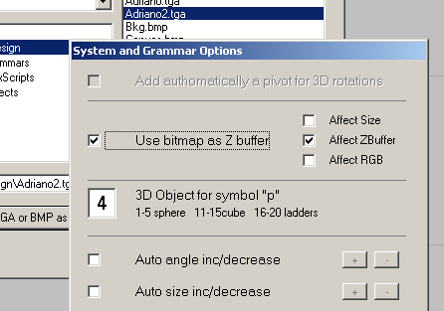
Load Bitmap and set the ZBuffer option in the Option palette

Actually only the Z buffer and the color options are supported.
To import a bitmap, load .tga or .bmp image using the File option of the main menú, then in the grammar window open the Options palette and validate the ZBuffer/size affect option. Adjust the postition and size of the objects to match the bitmap values.

6. Parameters and display

6.1 Parameters

A very useful facility of GDesign is the parameters palette. Here you can set the number of iterations, the size of the objects for the main system or for the subsystems, the rotation angles and the value of the size modifier (the symbols “:” and “|”)
So a finished grammar can generate many different structures, depending on the parameters values.
The greatest variations are obtained with combinations of standard objects with subsystems, because they have independent parameters.

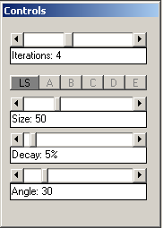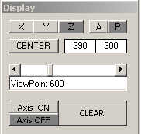
The Controls palette The display palette

To assign the size value to the main system, press the LS button, to assign size to A subsystem, press the A button, etc. Only size Works with subsystems, the angle option will be implemented as soon as possible.

6.2 Display

Here you can set the view to display the system: front (Z), right (X), top (Y).
Press “P” for the prospectic mode, “A” for the parallel mode.

To move the camera near or far, change the viewpoint with the slider control.

Center moves the origin of the system in the center of the canvas window. You can adjust the position pressing the icons on the border of the canvas window.

If you want to display the axis oif the objects, press “Axis On”

- Files

Grammars and subsystems are saved as ASCII files, grammars with the extension .cad or .grm (GDesign 3.0) and subsystems with extension .sub.

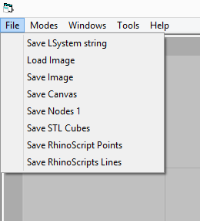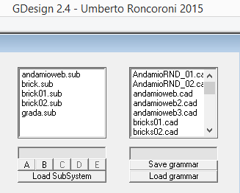

It is possible save and load complete LSystems with extension .sly or .LSM (GDesign 3.0).

But you can just change the extension from .cad to .grm or from .sly to .LSM and viceversa…

Export

You can export points to Rhino using RhinoScripts, .ms script file for 3DSMax and .pov for POVRay. Remember to validfate the checkbox.

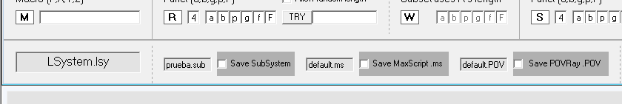

It is also possible to export cube objects files in .STL Stereolitho file format, to interface with rapid prototyping machines or 3D printers.

Scripts also are ASCII files, like grammars and LSystems strings.

Bitmaps are parsed only in Standard Truevision .TGA 24 bit file format or BMP format.

- Handling errors

GDesign is working OK, but some errors or unespected behaviors can occur because of sintactic error or illegal operations (the parser only sometimes advises the user of these exceptions). Here is a list of common mistakes that may cause problems (but GDesign will not crash, it just does not perform as you are expecting…). So:

- Avoid rules with too many symbols, this will generate a very big system, may be the system could go out of memory.
- Do not use rotations, macro and functions in grammars that you want to use as subsystem.
- Always specify the rotation axis with the first rotation, if not, the parser will ignore every angle modification. For example:
aaaP+bbb-a the symbol + and - will be correctly parsed
aaa+bbb-a the symbols + - will be ignored and all the following rotate modificators until a P or T or D is found.
- If nothing is displayed, check if objects have been assigned to symbols
- Remember to close your brackets. A [ must be closed with a ]
- Remember to link a file when using subsystems symbols A B C D E. If you don’t link a file to these symbols, nothing will be displayed.

And finally:

Generative production can be very difficult to predict, sometimes GDesign seems to do strange things, but this depends on the complexity of grammar design.
Do not get frustrated, build your grammars step by step, it is very useful to draw by hand the basic idea of the structure you want, and then experiment with the possibilitiess of the generative process.
But this is precisely the idea: to study natural system and simulate them with LSystems. New things can be discovered this way, this is better than playing randomly with symbols and rules. Creativity must be carefully planned.

And the great Italian painter Giorgio Morandi used to say:

Amo la regola che corregge l’emozione
I love the rule that adjusts the emotions

And finally Dante:

Messo ti ho innanzi, ormai per te ti ciba
che a sè volge tutta la mia cura
quella materia ond’io son fatto scriba.

Umberto Roncoroni
March, 2017

Symbols and their production are marked with the same color, so in line 2 you can see the matching strings.

